**Sales Insights Data Analytics Project for AtliQ Hardwares Company**

**AIMS Grid for this project**

AIMS grid is a very useful tool to improve **Project Management skills** for Project managers, Team Leaders etc. It helps to clarify a task and keep the process simple. AIMS grid presents a project in a very **concise** manner.

**Purpose**

To unlock sales insights that are not visible before for sales team for the decision support & automate them to reduce the manual time spent in data gathering.

**Stakeholders of this projects**

* Sales director
* Marketing team
* Customer service team
* Data & Analytics team
* IT

**End Result**

An automate dashboard providing quick & latest sales insights in order to support data driven decision making.

**Success criteria**

* Dashboard(s) uncovering sales order insights with latest data available.
* Sales team able to take better decisions & prove 10% cost saving of total spend.
* Sales analysts stop data gathering manually in order to save 20% of their business time and reinvest it value added activity.

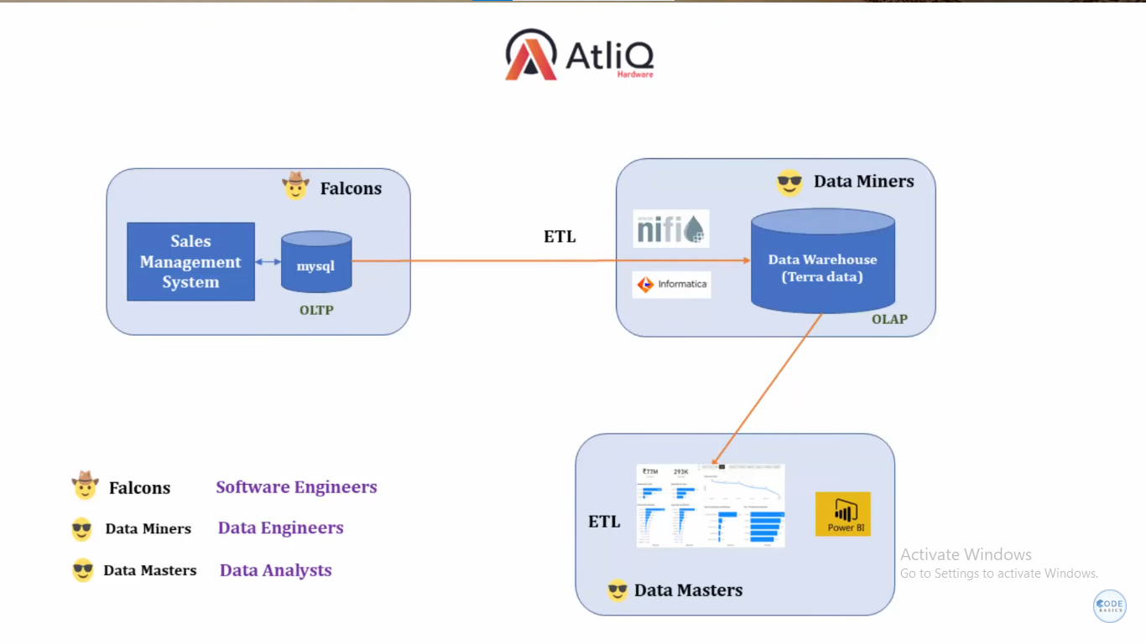

**Data Analysis using MySQL**

1. First create a new server in MySQL called ‘Dev_sales_insight’. Then click on it.
2. Then go to ‘Server’ tab, then select ‘Data Import’, then check “Import from self-Contained file”, then browse the file called ‘db_dump’ from the local system, then click on OK.
3. **Then click on ‘Import Progress’ beside button,** then click on ‘Start import’**.**
4. After the import done, in the ‘SCHEMAS’, press the refresh button to see the ‘sales’ data base has been created.

**Codes are in the SQL query folder**

**Connect Power BI with MySQL**

Open the Power BI, then go to ‘Get data’, then click on ‘More’, then select ‘Database’, then select ‘MySQL database’, then click on ‘Connect’.

After that, it will ask for which ‘Server’ give ‘localhost’, then for ‘Database’ give ‘sales’ as shown below.

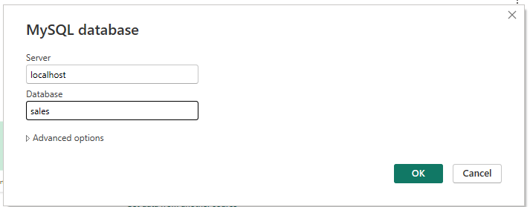

After that it will ask for username and password, in place of ‘Username’ give ‘root’, then in ‘Password’ give ‘PHW********’, then it will connect with our server.

Then select all the tables, then give ‘Transform Data’, now the data is loaded into our Power Query.

**In Market table**

Remove the ‘New York’ and ‘Paris’ by filtering the ‘zone’ column blank values

**In transaction table**

Remove the ‘0’ and ‘-1’ by filtering the ‘sales_amount’ column 0 and -1 values.

Then add a new column by giving ‘Conditional column’ operation, then give values as below

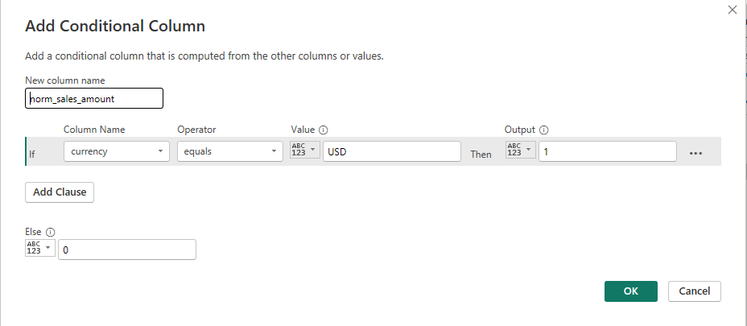

Now in the same conditional column we have to alter the formula as per our requirement. This will help to convert USD currency into Indian rupees. After we change the formula, it will get updated to ‘Custom column’ by its own.

"norm_sales_amount", each if [currency] = "USD#(cr)" then [sales_amount]*75 else [sales_amount])

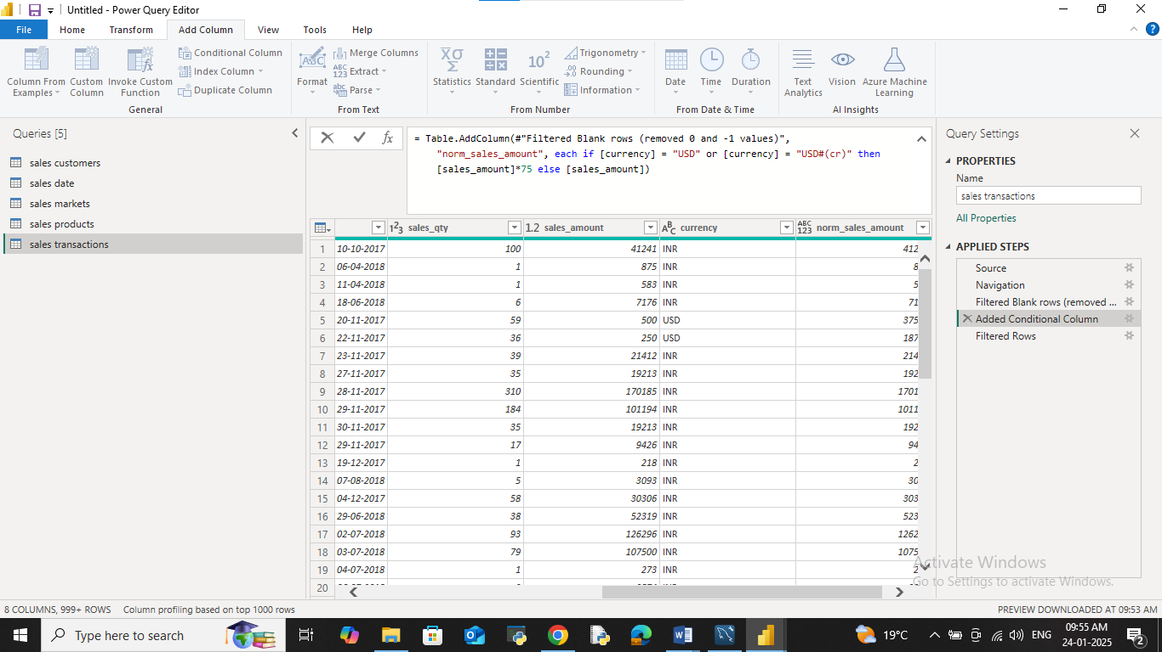

**Data Modelling**

In Model view, some of the connections are done by Power BI automatically between ‘transactions’, ‘customers’ and ‘products’. Now we have to build the relation between ‘date’ and ‘markets’ table with ‘transactions’ table.

Drag ‘market_code’ from ‘transactions’ table into ‘markets_code’ of ‘markets’ table and next ‘order_date’ from ‘transactions’ table into ‘date’ of ‘date’ table.

**DAX functions**

Create a new table using ‘Enter table’ in Power BI Home tab, to keep all the measures in one place & name it as ‘BaseMeasures’.

1. Revenue = SUM('sales transactions'[sales_amount])
2. Sales Qty = SUM('sales transactions'[sales_qty])
3. Total Profit Margin = SUM('Sales transactions'[Profit_Margin])
4. Revenue LY = CALCULATE([Revenue],SAMEPERIODLASTYEAR('sales date'[date]))
5. Revenue Contribution % = DIVIDE([Revenue],CALCULATE([Revenue],ALL('sales products'),ALL('sales customers'),ALL('sales markets')))
6. Profit Margin Contribution % = DIVIDE([Total Profit Margin],CALCULATE([Total Profit Margin],ALL('sales products'),ALL('sales customers'),ALL('sales markets')))
7. Profit Margin % = DIVIDE([Total Profit Margin],[Revenue],0)

Profit_Target

1. Profit Target Value = SELECTEDVALUE('Profit_Target'[Profit Target1])
2. Profit Target1 = GENERATESERIES(-0.05, 0.15, 0.01)
3. Target Diff = [Profit Margin %]-'Profit_Target'[Profit Target Value]